**Assignment -4**

Digital Marketing

|  |  |
| --- | --- |
| Student Name : | Krishnan S |
| Student Roll Number : | 20URCS024 |
| NM ID : | CD411E78561DFDBA7E44B709DE792134 |
| College Name : | AAA College of Engineering and Technology |

**QUESTION:**

**Create email newsletter design using MailChimp or Canva tool. EMAIL NEWSLETTER USING CANVA:**

**Newsletter link:**

[**https://www.canva.com/design/DAFtY3Ig_IU/0ufYcsJSEOqx0ZZhzH1Fqw/edit?utm_content=DAFtY3Ig_IU&utm_campaign=designshare&utm_medium=link2&utm_source=sharebutton**](https://www.canva.com/design/DAFtY3Ig_IU/0ufYcsJSEOqx0ZZhzH1Fqw/edit?utm_content=DAFtY3Ig_IU&utm_campaign=designshare&utm_medium=link2&utm_source=sharebutton)

**Newsletter Title: Srivi Sweets**

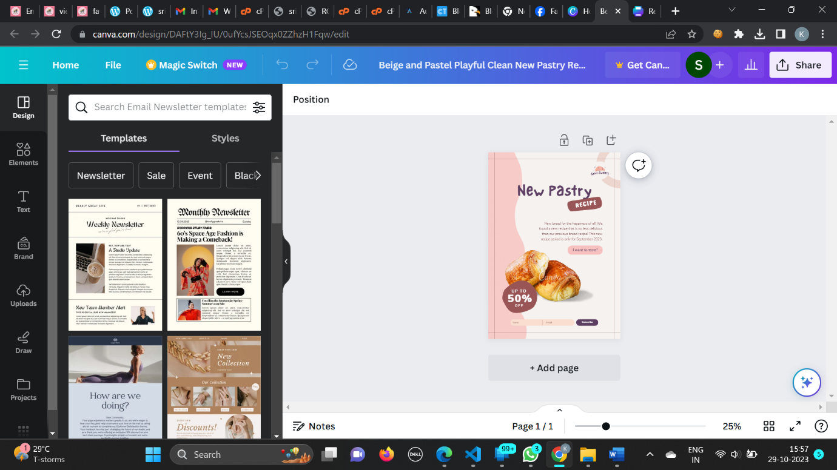

**Poster :**

